Graphical Abstract
The thermodynamic studies of 6-(4-chlorophenyl)-1, 2, 3, 4-tetrahydro-2,4-dioxopyrimidine-5-carbonitrile in 60% DMSO in the temperature range 298 to 313 K
Manoj R. Gaware

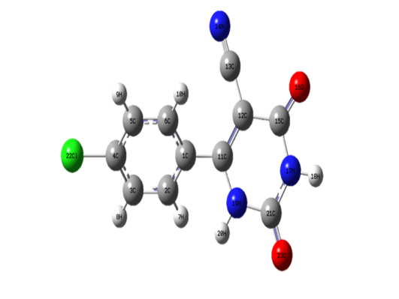
60% DMSO

